feeling lucky?

feeling lucky?

feeling lucky?

Feeling lucky?

Feeling lucky?
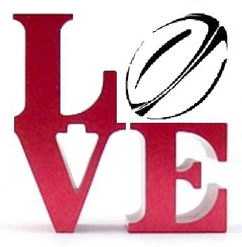
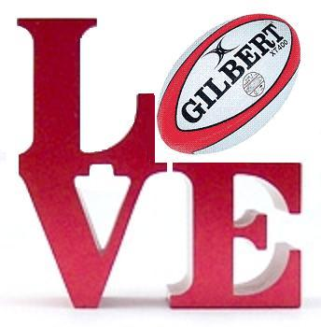
5th Annual Kildare’s
Cheesesteak 7’s
7.7.07
5th Annual Kildare’s Cheesesteak 7’s
7.7.07

